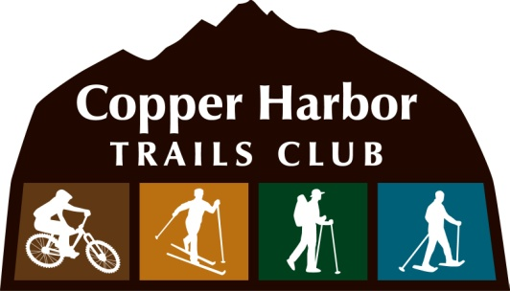
P.O. Box 37
Copper Harbor, MI 49918
April 27, 2014

City of Duluth
411 West 1st Street
Duluth, MN 55802

Re: Letter of Recommendation - Rock Solid Contracting LLC.

To Whom it May Concern:

At this time, we would like to express our utmost confidence in Aaron Rogers, Rock Solid Trail Contracting LLC. Over the years as an employee, volunteer and also as a contractor for the Copper Harbor Trails Club – IMBA Chapter, Aaron has planned out and implemented a strategy for success that included all aspects of trail development. In any give year, Aaron organized multiple trail projects and managed equipment and work crews effectively and efficiently to completion despite a short building season.

Today Copper Harbor is recognized as a Silver Level IMBA Ride Center and it is due in large part to Aaron’s eye for trails and ability to complete projects. From beginner trails to expert downhill trails, Rock Solid Contracting can do it all. Aaron and his crew have a skillset that goes beyond operating machines and a work ethic that is unparalleled. We wish Aaron and Rock Solid Trail Contracting LLC luck in their pursuit of new projects that will grow mountain biking in the region.

If you should have any questions or need any additional information, please contact me at (906) 487-6635 or via email, lori@copperharbortrails.org

Sincerely,
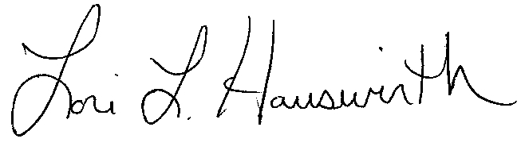

Lori L. Hauswirth,
Executive Director

