Wilderness Property Management Inc.

WPM Inc. has created two very successful mountain bike parks that have had a great impact on the sponsoring communities. Videos of these parks have been placed on You Tube for the promotion of WPM and the communities of North Creek and Queensbury in Warren County, New York.
Video representation is the preferred way of representing the mtn. bike experience. Please visit the following two links to the North Creek Ski Bowl Park mountain bike video and the Gurney Lane Mountain Bike Park video to view what these trail systems offer.
https://youtu.be/kOcriCqDMJo
https://youtu.be/dG1HN0cab3g

WPM Inc. and Chief Operating Officer Steve Ovitt received the 2015 Wild Stewardship Award from Adirondack Wild: Friends of The Forest Preserve, the oldest Adirondack Forest Preserve protection organization, for fostering wilderness stewardship, the education of young people and creating beautiful trails and bridges compatible with wild outdoor settings.

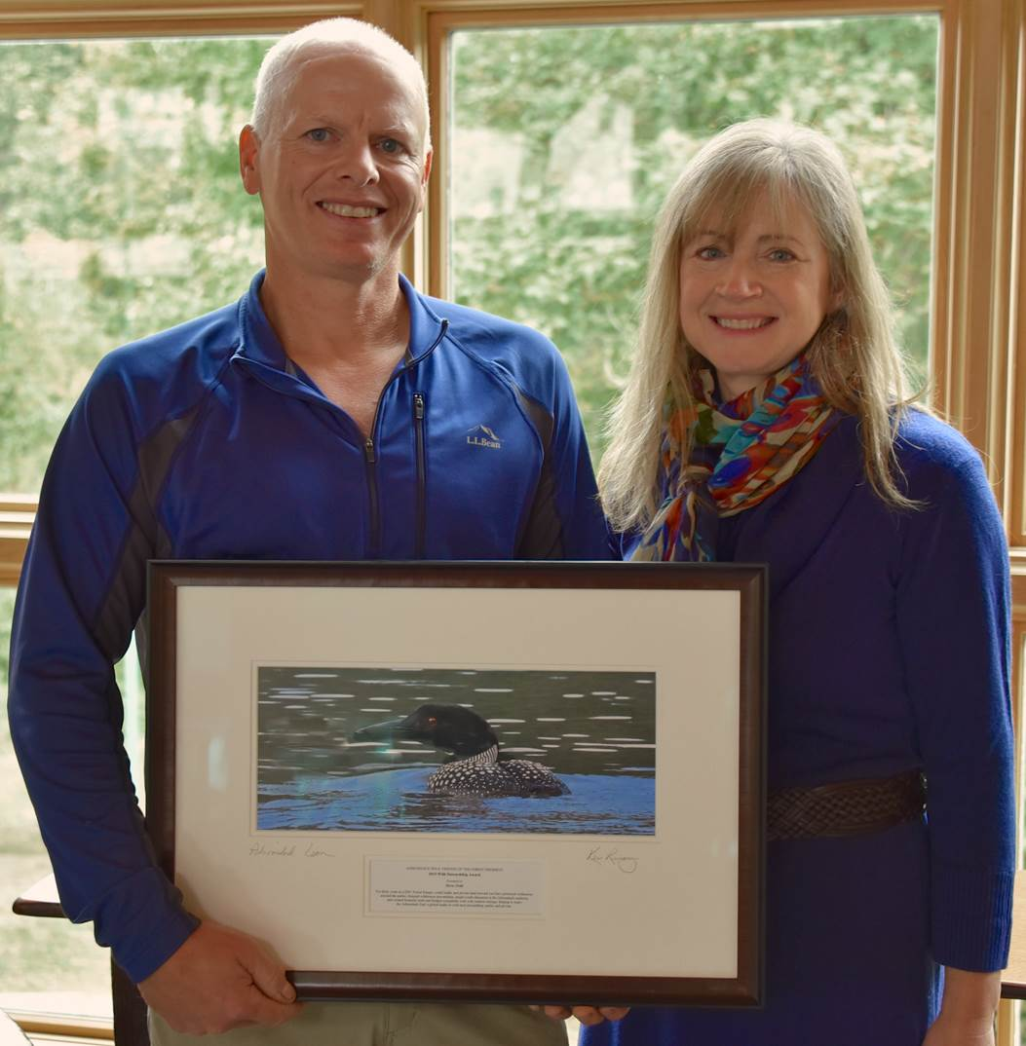

Please visit the WPM Inc. website for more pictures and business information.
www.WildernessPropertyManagment.com

